***Game Programming course Assessment 1***

**Unit Testing:**

1. There was an issue with loading the text file back onto the console.

**What the issue was?**

The issue was that whenever the player had finished with selling or buying an item from the shop keeper and proceeded to launch the console again, the code produced the original content of the items within the store and the players items. Overall meaning that the text files were not loading back up onto the console again.

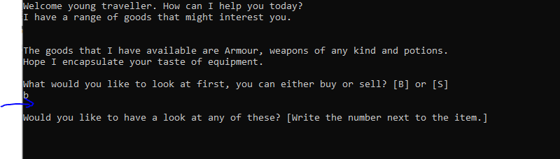Example A: Example B:

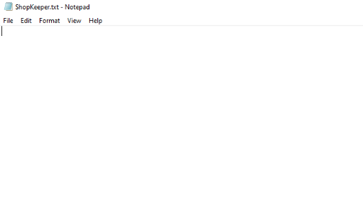

Example C:

As seen above, example a, where the blue arrow is pointing, is where the array of different items is supposed to be displayed. However, within the text file of example b, shop keeper doesn’t have a single item within it. Meaning that it is never being written too the text file to be loaded back into it. In example C, the text file would be displayed as an item types, name, weight, cost and the three variables that are found within the other classes.

**What did I do to fix it?**

Example D:

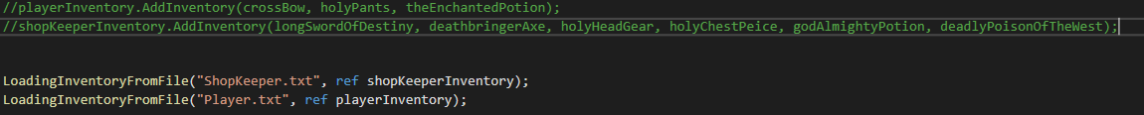

The main way to solve this issue was to create an already made text file of the array of items. You cannot just have a text file without the actual text within it. However, this would mean that I would need to delete a few lines of code within my main function after the text file has been saved.

Within Example D, the top two lines are adding a range of items into their inventory to be later saved and moved into “MovingArrayToFile”. This allows for the text files to be made. However, to continue updating and saving the functions, these lines need to be commented out or deleted from the script. The bottom two need to be commented out first as they are looking for text files that don’t exist. After the text files are created, then the loading function can work.

1. Issues with the wrong name, weight and cost of item coming up when displaying to the console.

**What the issue was?**

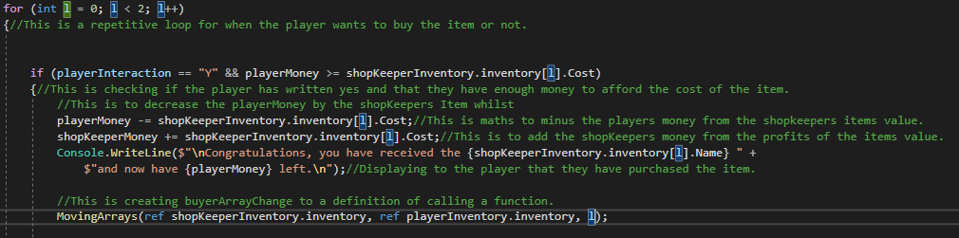Example E:

When the player was either selling or buying an item from the shop, there was a logical error that would occur in terms of a different items eight, name and cost would pop up whenever I would want to print, “Congratulations, you have received {Name} and you now have {playerCost}”.

In example E, the player would have their values of money calculated and then the player would get a message saying congrats, you have received this item whenever they have said yes to the item and that their playerMoney is more than the cost.

**What did I do to fix it?**

Example F:



Example G:

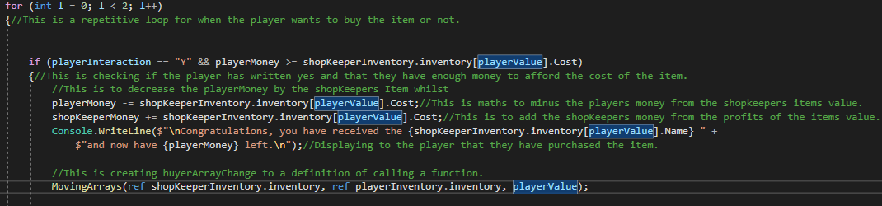

I accidentally was using the variables “L” to define the location of the item within the inventory whereas, it is only a for loop over the program, not the item itself. As can be seen in example F, I was converting the playersInteraction (their input) to a integer so that, from example G, find that the player has said yes and that they have the right funds for the item, that the cost decrease will be correct and that the console will produce the correct item sold.